**Narrated Landscapes**

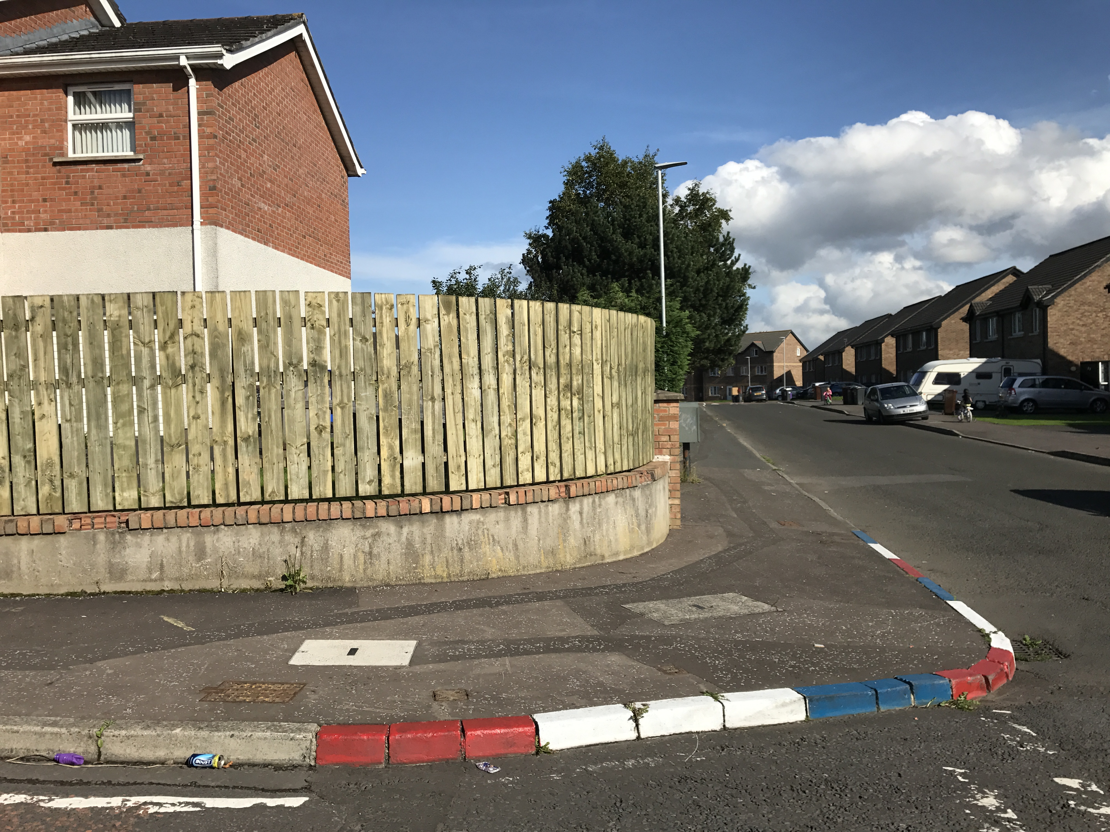

Thirty-three residents of North Belfast participated in walking interviews as part of the Belfast Mobility Project. During these walks, which usually lasted between 45 minutes and two hours, participants were asked to imagine they were tour guides, taking the researchers on a typical journey through their local area to discuss the impact of community divisions and the associated symbolic landscape on their perception and use of space.

Here, two tracked walks demonstrate markedly different patterns of movement between a Catholic participant from Ardoyne and a Protestant participant from the adjacent Glenbryn neighborhood. Their respective perceptions of threat, shared space and communal identity differ in ways that help to sustain activity-space segregation. In the maps below, click on the numbered icons to hear the participants’ commentary about how features in the landscape and broader social dynamics impact their mobility choices.

**INSERT WALKING INTERVIEW MAPS/AUDIO ANIMATION for Participants 37 and 51. Label them as Participants A & B respectively.**